Water Reserve System for Cabinet Incubator
Float clip adjustment options

There is a recent change in the water tray that comes with GQF’s cabinet incubators. The original has side flanges, the new version has no side flanges. They both work equally as well.

No Side Flange
Side Flange

If your tray has side flanges, the original clip that comes attached to the float will work. If your tray has no side flanges, see the instructions below for two options to adapt the 3031 water reserve system to your tray.
Option 1:
There is an indent in the side of the tray designed for a float to go through.
- Open the hole by using a ½” drill bit or a screwdriver to punch out the hole.
- Remove the float from the bracket it came attached to by loosening the large plastic nut.
- Adjust the angle of the float by loosening the small screw, moving the float up and re-tightening the screw.
- Insert the float in the side of the water tray and tighten the nut. Ensure the float is straight.
- Test the float to ensure the water level does not get any closer than 1” below the top of the water tray.
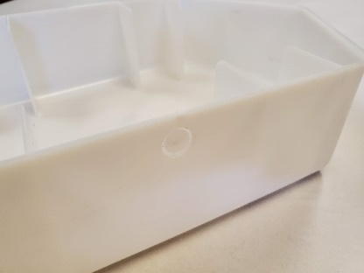
Hole Indent
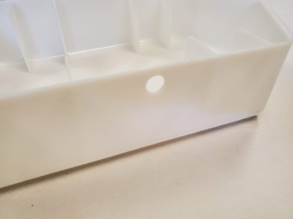
Punch out with screwdriver or drill out with ½” drill bit

Adjust float angle
Mount in water tray

Option 2:
Use the updated clip designed for the tray without the flange.
- Remove the float from the bracket it is attached to by loosening the large plastic nut.
- Re-assemble the float in the updated clip and tighten the nut. Ensure the float is straight.
- Put the clip into place.
- Attach the securing sticker. This is to ensure the float does not slide up over time. It normally is not needed, but it acts to ensure there is no movement of the clip over time. There is a spare included for future use.
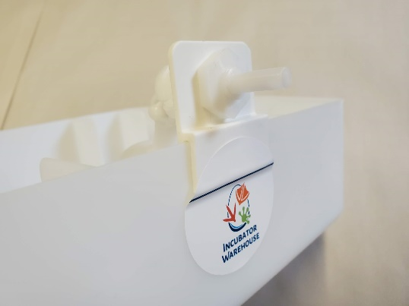
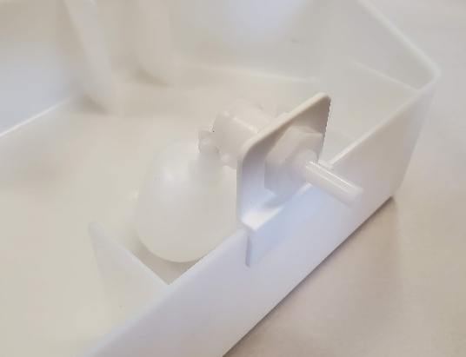
- Test to ensure that water level does not get any closer than 1” below the top of the water tray.
Attach securing sticker
Mount on water tray
Secure float in modified clip
Original Clip
Original float from clip

